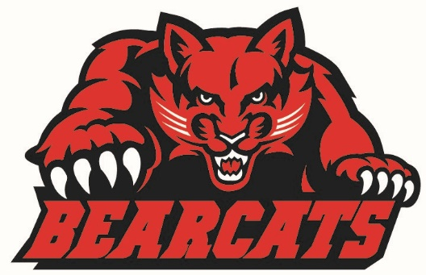
PORK BUTTS & BABY BACK RIBS
The Brookland Lady Bearcat Basketball team is having a smoked Boston butt and baby back rib sale as a fundraiser. All proceeds go to support the girls’ basketball program. On behalf of our players, coaches and parents, thank you for your support!
- Ribs and Butts are $25 each
- Orders due September 2
- Butts will be 4-5 lbs, ribs 3-5 lbs
- Delivery date is September 9 in front of the high school
- We will be here from 3 until after the football game

ORDER FORM (All sales are by pre-order and must be prepaid)

Name_____________________________________
Evening Ph. #________________

I understand pickup is my responsibility. _______ (initial)

Smoked Butt (approx. 4-5 lbs. precooked) $25.00 each X_________ = _________

Smoked Ribs (approx. 3-5 lbs. precooked) $25.00 each X__________=_________

TOTAL=_________

Paid Cash: _________ Paid Check #:_________

Make checks payable to: Lady Bearcat Basketball

Order Deadline: _____Friday September 2, 2010_______

Pick Up: ___Friday, September 9, 3pm-9pm______
Brookland High School (front of school)

Contacts: Coach Baltz jbaltz@bpsbearcats.com Coach Ellis aellis@bpsbearcats.com

